Priorsford Primary School
Positive Behaviour Policy

April 2012

Updated August 2013

Positive Behaviour Policy

At Priorsford Primary we aim to provide all our pupils with a caring and happy environment where we can teach and learn in a positive and encouraging way. Everyone should show respect and consideration to others and be co-operative, welcoming and treating others fairly and with care. Pupils should show awareness of their surroundings and act appropriately, being proud to represent the school by wearing the school uniform.

Everyone involved in the school – pupils, staff and parents/carers – should take responsibility for promoting a positive ethos in the school and respectful relations so that pupils can learn in a safe environment to achieve their best. Pupils will play an active role in all decisions that affect them and they will know that their voice will be heard and valued.

Priorsford Primary School is a Rights Respecting School which means that we uphold the UNICEF values, based on the United Nations Convention on the Rights of the Child (CRC). The Convention outlines, in the form of rights, what adults must do to enable children to grow and be healthy; to learn; to receive protection; to have their views listened to and to be treated fairly.

As a Rights Respecting School, all pupils at Priorsford know that they have:

- A right to be listened to
- A right to be safe and supported
- A right to learn
- A right to play with friends
- A right to be respected

We have created a school charter based on these rights, which has been written and agreed by pupils, staff and parents – see appendix 1. This was created by the Pupil Council in consultation with all other pupils and then agreed with staff and parents.

At the centre of this charter is the school and the values we uphold. The key rights from the CRC are listed and pupils have agreed what behaviours we all expect to enable us to uphold this charter.

This school charter is supported by classroom charters, written and agreed by pupils and the class teacher. Class charters will be reviewed annually. These reinforce what rights and behaviours the pupils and staff in each class should expect in a positive and supportive classroom environment.

To be fair and consistent, this behaviour policy clearly sets out the expectations for everyone in promoting a positive and rights respecting ethos at Priorsford.

Expected Standards of Behaviour

The expected standards of behaviour of pupils on the way to school, at school and on excursions are detailed in appendix 2.

To promote self esteem and a positive and achieving ethos in school, good behaviour and actions should always be recognised. Pupils have discussed and agreed how behaviour will be positively recognised – see appendix 3 for full details.

For pupils who do not respect the rights of others, then clear, fair and appropriate behaviour management strategies and sanctions have been discussed and agreed with pupils, parents and staff – see appendix 4 for details.

Conclusion

At Priorsford, we aim to create a safe, happy, respectful and positive environment for effective teaching and learning to take place. It is everyone’s responsibility to ensure that, by following the policy, everyone can enjoy their rights. This policy will be reviewed regularly to ensure pupils’ needs and rights are met appropriately.

In order for us to achieve this aim, this policy requires the cooperation and support of all our parents/carers. Therefore, we would expect you to read and discuss this policy then sign the attached form acknowledging that you and your child (ren) have read and understood this policy.

April 2012
August 2013

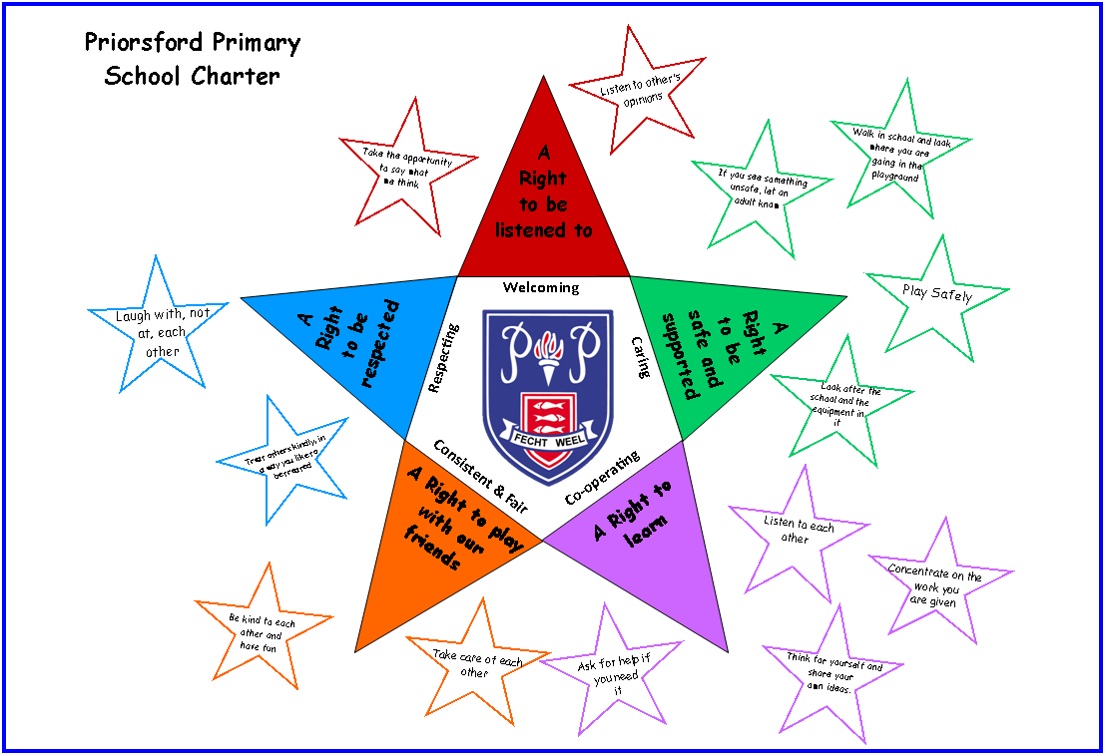

Appendix 1 – School Charter

Appendix 2 – Expected Standards of Behaviour

To and From School
As soon as pupils leave home for school, they are representing the school and should behave appropriately. Pupils should respect other people and their property. Walking to school in a safe and sensible manner is encouraged and pupils should use the designated road crossings.

Pupils travelling on school transport have added responsibility of making sure they behave in a safe manner at all times; wear seatbelts at all times when they are travelling on the school bus and follow the driver’s instructions at all times.

At School
Once pupils come under school supervision, their safety becomes the responsibility of the school. The school playground is supervised from 8.50am and so pupils should come to school as close to 9am as possible. If pupils are accompanied by their parents/carers until the bell rings, then supervision in the playground is the joint responsibility of the school and parents. If pupils are cycling to school, for the safety of all, they must dismount and walk with their bikes within the school grounds.

Lining Up and Entering School
A warning bell will ring just before 9am and pupils should line up in houses, ready to go into school in a quiet and orderly manner. Teachers will come to collect their class. Parents/carers should stand well away from these lines at this time to allow pupils and staff to get into school promptly. House points are awarded by staff for the best lines.

Cloakrooms
Pupils should then go straight to the cloakroom and hang coats on pegs; change into indoor shoes, take everything they need for class from their schoolbags and put bags away neatly. Pupils should bring a pencil and a rubber to school every day. Schoolbags are personal property and no–one should go into anyone else’s bag. Pupils should then go quietly and quickly to class.

Classroom Behaviour
As with behaviour in all other areas of the school, pupil behaviour in the classrooms should reflect the right that everyone has to learn, a right to be listened to and a right to be respected.
Classroom charters will be agreed with all pupils and the teacher to make sure everyone knows what is expected of them and that learning can take place in a safe and respectful environment.

The tracking sheet in the classroom should be used as a sanction to ensure that everyone can learn in a safe and happy environment and that their Rights are being met.

Break and Lunchtime
Before lunchtime, the teacher should take the class to the cloakroom. Pupils should then change shoes and go outside in a calm and safe manner.

When it is time to go for lunch, pupils must follow the playground supervisor’s instructions, walk into the dinner hall quietly and wait to be given a seat. Appropriate behaviour is expected at all times whether in the dinner hall or if having lunch outside. Packed lunch boxes should be put into the correct lunch bag when lunch is finished. To help staff and keep the hall clean for others, pupils should clear away rubbish to show that they are ready to leave. Recycling bins should always be used to cut down on waste.

In the playground
Pupils must always try to take care of others around them and show respect for other pupils as well as any adult in the playground. Pupils should include others and play well together to make the playground a safe and happy place for everyone. Swearing is never appropriate for the school playground and any pupil caught swearing will immediately go on the tracking sheet.

For everyone’s safety, pupils should always follow the rules for playing on the equipment and should follow instructions given by adults as soon as possible. If there are rotas for playing on the equipment or for games, pupils should keep to these and not spoil the enjoyment of others. If someone has been injured, please let an adult know so that they can arrange for help.

On School Trips
School uniform should be worn on every school trip, unless told otherwise. It must be remembered that pupils are representing the school and must be aware of and show respect to members of the public. Pupils should take instructions from any adult accompanying the class as well as those people teaching the group at the visit. For safety reasons, all pupils must behave and consider others on public transport. If a pupil misbehaves on a trip and endangers themselves or others, then they will be brought back to school. Pupils who cannot behave appropriately in school will not be allowed to go on an excursion if this means the safety of others might be affected.

Mobile Phones
Pupils should not have a mobile phone with them during school time. If a pupil brings a mobile phone to school, then it should be switched off and given to the teacher for safe keeping until the end of the day.

Appendix 3 – Recognising and Praising Pupils

To promote self – esteem and a positive and achieving ethos in school, good behaviour and actions should always be recognised.

This is done in both the classroom and in all other areas of the school environment.

Examples of whole school approaches to recognising good behaviour include:
- House points awarded by all staff for positive behaviour around the school and thoughtful actions by pupils.
- Extra playtime on a Friday afternoon for the house with most house points.
- Star Pupils awarded at assembly every week to individual pupils. Photos of these pupils are displayed on the Star Award board and on the plasma screen outside the office and in the dinner hall.
- Golden Time on a Friday afternoon for all pupils who have earned this reward.
- Termly Headteacher Awards
- Winning House reward activities arranged termly by House Captains

Appendix 4 – Procedures for Sanctions

Management of pupil behaviour is the shared responsibility of both staff and parents and must be consistent and fair. Certain pupils may have personal positive behaviour strategies and so may have sanctions which may differ from the rest of the class. These strategies are devised by relevant professionals in collaboration with the pupil, parents/carers and staff and will be tailored to suit the individual needs of the child.

Inappropriate playground behaviour is recorded by staff. Most indiscipline can be dealt within school by staff – ANAs may be the first point of contact in the playground and they can either deal with the issue, or they may report the incident to the class teacher. If indiscipline continues, or is more serious, then the pupils will be referred to the HT or DHT and parents/carers may become involved.

The first formal sanction for misbehaviour will be a verbal warning given by the class teacher or additional needs assistant. If this warning is ignored and the poor behaviour continues, then the pupil will go on the tracking sheet and lose all Golden Time on Friday. During missed Golden Time on Friday, the pupil will receive a letter home for their parents/carers describing why they have lost Golden Time. This letter should be signed by parents/carers and returned on Monday. If a pupil is on a warning on the tracking sheet on three separate occasions during one week then, again, the pupil will miss all of Golden Time on Friday.

If a pupil receives a letter home three times during the term, or if the behaviour is dangerous or unsafe for themselves or for others, then parents/carers will be called immediately to meet with the HT/DHT.

For the most severe punishment, which would only be applied after discussion with parents/carers (and staged support if appropriate), a pupil may be excluded from school for a period of time.

When parents/carers have become involved in these latter stages of discipline, it is expected that they work in partnership with the school to try to find a positive way forward for everyone’s benefit.

